Jurnal  Teknologi |  |  |  | Full Paper
DEVELOPMENT OF TRANSFORMATION CONSTRUCT AND TRANSGENIC TOBACCO PLANTS CARRYING EgPAL5 GENE  Mohd Nordin Nursaadahª, Nur Syafiqah Shariful Bahriª, Omar Nawawiª, Mohamad Shafek Hilmanª, Muhammad Ikhwan Mughniª, Shamsiah Abdullahª, Tianqi Bai^{b}, Cuixian Zhang^{b}, Mat Yunus Abdul Masani^{c}, Chai-Ling Ho^{d}, Chong Yu Lok Yusufª*  ªLaboratory of Plant Genetics and Cell Biology, Faculty of Plantation and Agrotechnology, Universiti Teknologi MARA Jasin Campus, 77300 Merlimau, Melaka, Malaysia  ^{b}Institute of Tropical and Subtropical Cash Crops, Yunnan Academy of Agricultural Sciences, Baoshan 675800, China  ^{c}Malaysian Palm Oil Board (MPOB) No. 6, Persiaran Institusi, Bandar Baru Bangi, 43000 Kajang, Selangor, Malaysia  ^{d}Department of Cell and Molecular Biology, Faculty of Biotechnology and Biomolecular Sciences, Universiti Putra Malaysia, 43400 UPM, Serdang, Selangor, Malaysia |  |  | Article history  Received  X Month 202Y  Received in revised form  XA Month 202Y  Accepted  XB Month 202Y  *Corresponding author  yusufchong@uitm.edu.my
Graphical abstract  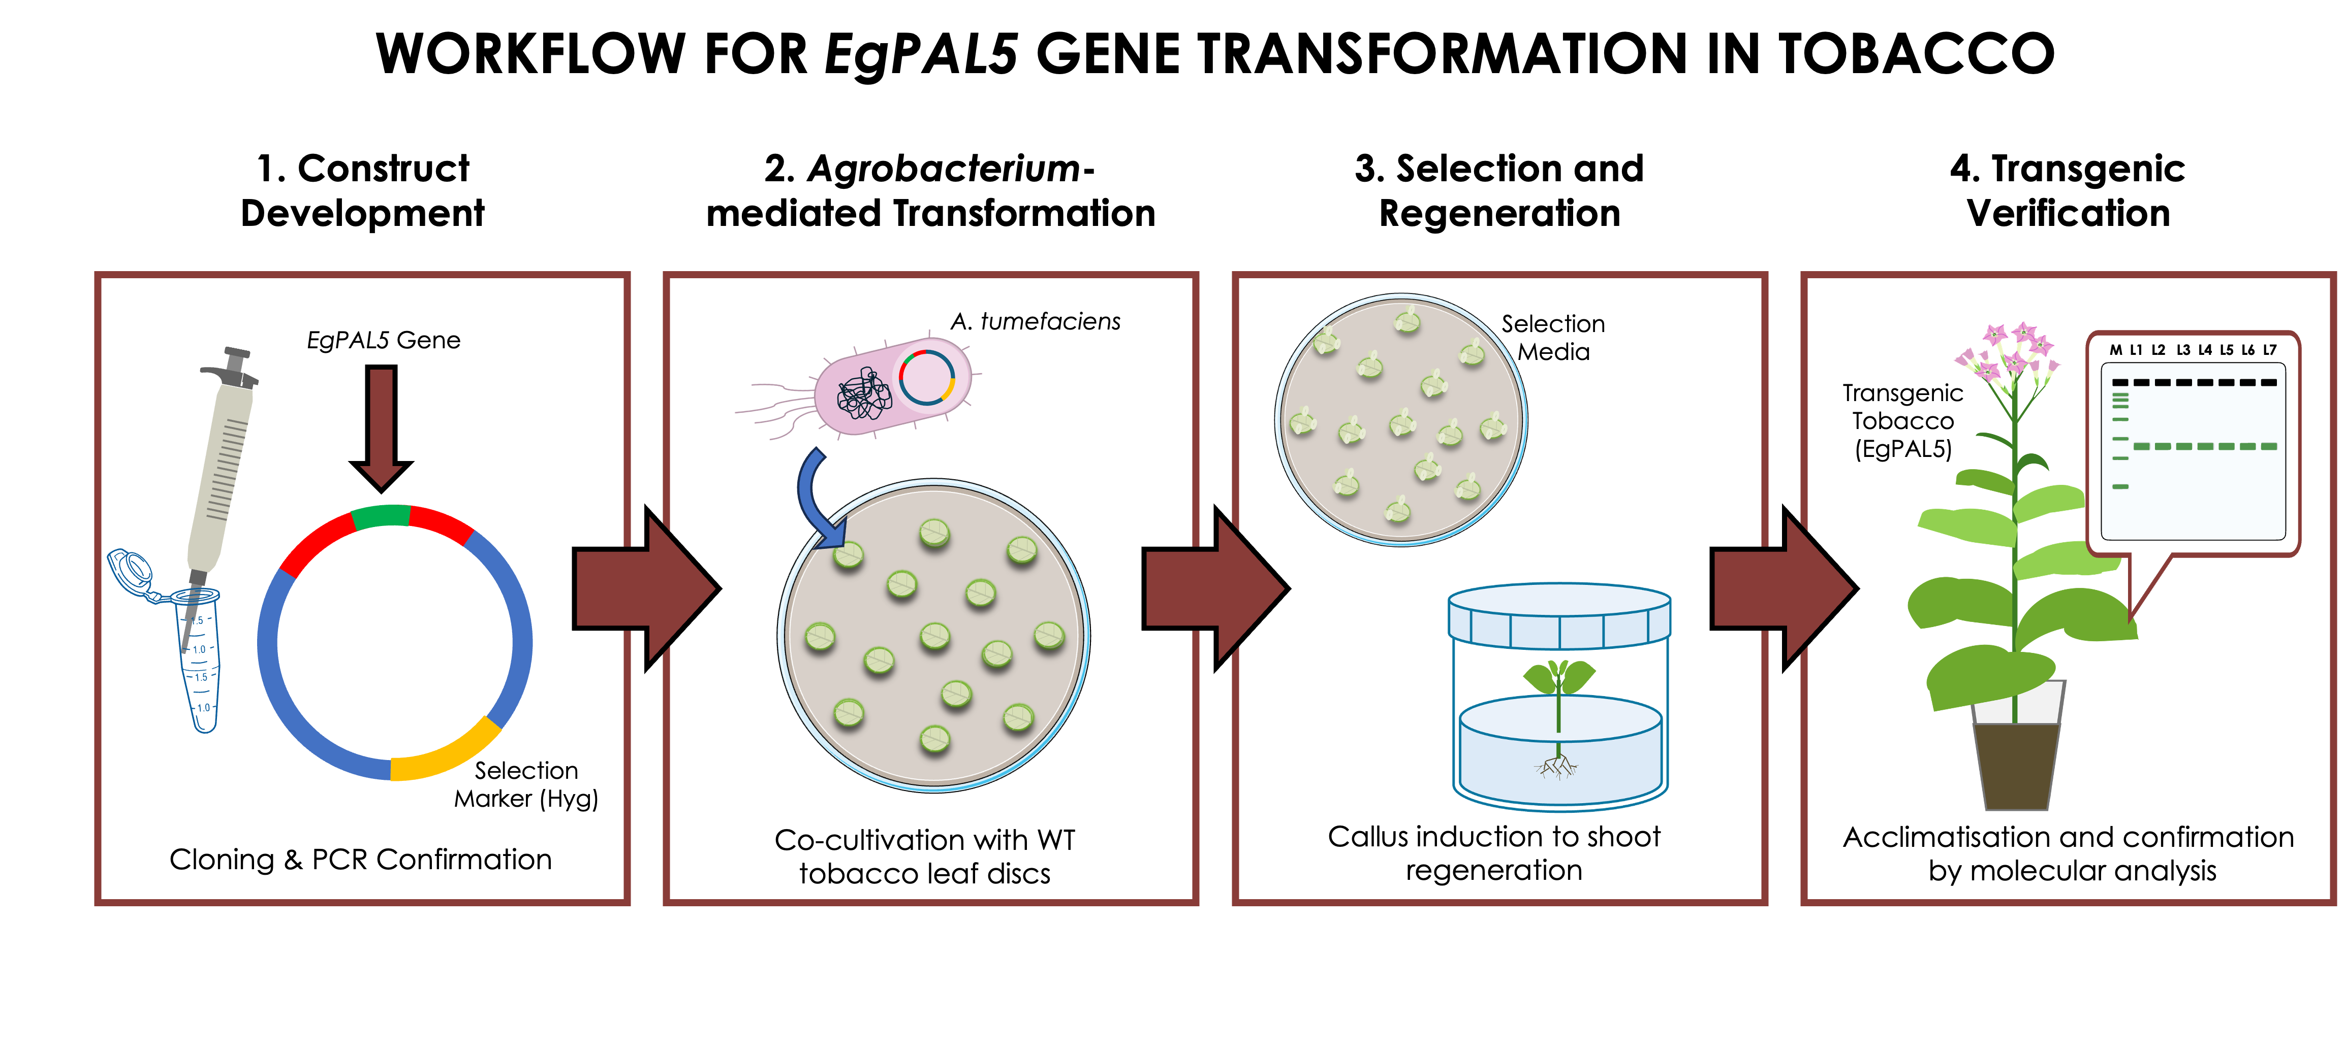 |  | Abstract  Tobacco (Nicotiana tabacum) is a globally significant industrial crop, yet its yield and productivity are frequently compromised by a diverse range of biotic and abiotic stresses. Developing crops with enhanced genetic potential is a crucial strategy to ensure survival and yield stability. This study reports the development of a novel genetic resource through the integration of the EgPAL5 gene from oil palm (Elaeis guineensis) into the tobacco genome. The 2,115-bp EgPAL5 gene was amplified, cloned into the pMDC32 binary vector, and introduced into tobacco plants via Agrobacterium-mediated transformation. Regenerated shoots were cultured on selective media containing hygromycin and timentin, maintained until rooting, and subsequently acclimatised to soil. Among 42 putative transformants obtained, 10 vigorous lines were selected for PCR verification, all exhibiting the expected amplicon size confirming stable integration of EgPAL5 transformation. This work successfully demonstrated the feasibility of incorporating the EgPAL5 gene into tobacco genome for crop improvement purposes, establishing a validated transgenic resource for future biotechnological applications.  Keywords: Agrobacterium-mediated transformation, molecular biology, Nicotiana tabacum, PAL, tissue culture
Abstrak

Tembakau (Nicotiana tabacum) merupakan tanaman industri yang signifikan di peringkat global, namun hasil dan produktiviti tanaman ini sering terjejas oleh pelbagai tekanan biotik dan abiotik. Pembangunan tanaman dengan potensi genetik yang dipertingkat adalah strategi kritikal bagi menjamin kelangsungan hidup dan kestabilan hasil. Kajian ini melaporkan pembangunan sumber genetik baharu melalui integrasi gen EgPAL5 daripada kelapa sawit (Elaeis guineensis) ke dalam genom tembakau. Gen EgPAL5 sepanjang 2,115-bp telah diamplifikasikan, diklon ke dalam vektor binari pMDC32, dan dimasukkan ke dalam pokok tembakau melalui transformasi berperantara Agrobacterium. Pucuk teregenerasi dikultur di atas media pemilihan yang mengandungi higromisin dan timentin, dikekalkan sehingga pembentukan akar, dan seterusnya diaklimatisasi ke tanah. Daripada 42 transforman putatif yang diperoleh, 10 titisan vigor telah dipilih untuk verifikasi PCR, di mana kesemuanya memaparkan saiz amplikon yang dijangkakan, sekali gus mengesahkan integrasi stabil transformasi EgPAL5. Kajian ini berjaya membuktikan kebolehlaksanaan pengintegrasian gen EgPAL5 ke dalam genom tembakau untuk tujuan penambahbaikan tanaman, seterusnya menghasilkan sumber transgenik yang sah bagi aplikasi bioteknologi pada masa hadapan.

Kata kunci: Transformasi berperantara Agrobacterium, biologi molekular, Nicotiana tabacum, PAL, kultur tisu

 |  | © 202@ Penerbit UTM Press. All rights reserved

1.0 INTRODUCTION

Tobacco is a perennial herbaceous plant native to South America. It belongs to the Solanaceae family, which encompasses brinjal, chilli, petunia, potato, and tomato. This crop has traditionally been associated with global cigarette production. Therefore, it is now cultivated worldwide because of its economic importance. According to Zhu et al. [1], China is the largest producer of tobacco, followed by India and Brazil. Tobacco can grow up to two meters tall and produces large leaves that accumulate high levels of nicotine [2]. In commercial varieties, particularly Nicotiana tabacum, nicotine levels can be increased to approximately 6.47% of dry weight through a genetic manipulation approach [2]. As a hybrid between N. sylvestris and N. tomentosiformis, N. tabacum is an allotetraploid plant that contains 48 chromosomes [3]. It can be easily transformed genetically, which makes it a useful system for plant biotechnology studies. Apart from that, tobacco is also used in environmental applications, including phytoremediation [4]. The plant can absorb high levels of heavy metals, including cadmium, from contaminated soils [5]. Such capability enables remediation of polluted sites while producing biomass for non-food applications. Furthermore, tobacco has been considered as a potential renewable resource for biofuel production owing to its high biomass production [6].
More interestingly, biotechnology advances have expanded the use of tobacco in molecular farming for the production of recombinant proteins, vaccines, and industrial enzymes [7]. Unfortunately, tobacco production is frequently affected by environmental stresses such as extreme temperature [8], drought [9], salinity [10], and flooding [11], which reduce yield and crop quality as a consequence. Apart from abiotic stresses, tobacco is also susceptible to infections caused by fungi, viruses, and bacteria. Several examples of the major diseases threatening the plant include Tobacco Black Shank (TBS) caused by the soil-borne oomycete Phytophthora nicotianae [12], Fusarium wilt (FW) caused by Fusarium oxysporum [13], Granville wilt (GW) caused by Ralstonia solanacearum [14], and Tobacco Mosaic (TM) caused by Tobamovirus tabaci or commonly known as Tobacco Mosaic Virus (TMV) [15, 16]. TBS is typically characterised by sudden wilting followed by stem blackening. FW and GW often begin with leaf yellowing and root decay. In GW, hollow stems and lesions may be observed, whereas FW often appears as unilateral chlorosis on one side of the plant. Lastly, TM typically induces chlorotic patches appearing as blotches, streaks, or spots, followed by vein discoloration, leaf curling, and morphological distortion [15, 17]. The above-mentioned abiotic and biotic stresses can significantly affect the productivity and economic value of tobacco crops. Under stress conditions, plants activate complex signalling pathways that redirect metabolic resources toward survival rather than growth [18]. At the structural level, plant resistance to abiotic and biotic stresses is closely associated with lignification.
Lignin forms a strong physical barrier that restricts pathogen entry and strengthens vascular tissues. In plants, lignin biosynthesis is predominantly regulated by phenylalanine ammonia-lyase (PAL), which catalyses the first step of the phenylpropanoid pathway and directs metabolic flux toward the production of various secondary metabolites. PAL is encoded by a multigene family [19], and its members are often expressed in specific tissues and upregulated under stress conditions [20]. Previous studies have shown that PAL contributes to plant growth and defence responses. For example, overexpression of GmPAL2.1 in soybean (Glycine max) enhances resistance against Phytophthora sojae by elevating PAL enzyme activity, increasing glyceollin accumulation, and activating salicylic acid (SA)-mediated signalling pathways that induce the expression of SA-responsive defence genes [21]. In wild legume (Lotus japonicus), LjPAL1 regulates lignin remodelling during Mesorhizobium loti symbiosis, and gene knockdown leads to excessive infection thread formation and nodule overproliferation [22]. Furthermore, in grass (Brachypodium distachyon), BdPAL1 knockdown reduced virus-induced SA and lignin accumulation [23]. Previously, Yusuf et al. [24] suggested that the EgPAL5 promoter played a major role in regulating the biosynthesis of stress-related secondary metabolites in oil palm. Collectively, these findings implied that heterologous expression of the EgPAL5 gene could improve stress tolerance in tobacco plants. This prompted us to introduce the EgPAL5 gene from oil palm into tobacco plants in the present study, producing stable transgenic lines for further studies.

2.0 METHODOLOGY

2.1 Vector Construction

The 2115-bp full-length coding sequence (CDS) of EgPAL5 was amplified from the pJET1.2-EgPAL5 plasmid obtained from Universiti Putra Malaysia. The reaction mixture contained 1× Q5 High-Fidelity Buffer, 0.2 mM dNTPs, 0.5 µM each of the forward (5’-TAA GGT ACC ATG GAG AAC GGC GGT GCT-3’) and reverse (5’-GCA CTA GTC TAA CAA ATA GGA AGG GG-3’) primers, 15 ng of template DNA, 1.2 U of Q5 DNA Polymerase (NEB, USA), and sterile distilled water to a final volume of 60 µL. The PCR was performed using the following thermal cycling profile: 98 °C for 30 s; 32 cycles of 98 °C for 10 s, 67-69 °C for 30 s, 72 °C for 75 s; and 72 °C for 5 min. The PCR product was purified from agarose gel using the PrimeWay Gel Extraction PCR Purification kit (1st BASE, Singapore). Next, the purified PCR product and pMDC32 plasmid were double digested with KpnI and SpeI restriction enzymes overnight at 37 °C. The insert DNA was ligated with the linearised pMDC32 vector using T4 DNA Ligase (Thermo Scientific, USA), generating the pMDC32-EgPAL5 construct. The ligation product was transformed into Escherichia coli, strain DH5α competent cells, and positive clones were confirmed by colony PCR, followed by Sanger sequencing. The verified transformation construct was subsequently transformed into Agrobacterium tumefaciens strain LBA4404 by electroporation.

2.2 Plant and Agrobacterium Preparation

Tobacco (N. tabacum) seeds were surface-sterilised using 0.5% (v/v) sodium hypochlorite for 10 min, followed by three rinses with sterile distilled water. Approximately 20–25 seeds were sown per plate on Murashige and Skoog (MS) basal medium solidified with 2.5 g/L Gelrite and germinated under a 16/8-h light/dark photoperiod at 25 °C for four weeks to obtain aseptic donor plants. Single colonies of A. tumefaciens carrying the T-DNA were selected from LB agar plates supplemented with 25 mg/L rifampicin, 50 mg/L kanamycin, and 100 mg/L streptomycin. The selected colony was inoculated into 25 mL LB broth, containing the same concentration of antibiotics. The culture was incubated overnight at 28 °C with 250 rpm agitation. Prior to transformation, the bacterial culture was pelleted by centrifugation at 4,000 × g for 10 min at 4 °C. The supernatant was discarded. The pellet was then resuspended in liquid MS basal medium to an OD₆₀₀ of 1.0 as inoculation medium.

2.3 Agrobacterium-mediated transformation

Plant transformation was performed according to Hilman et al. [25]. Leaf discs (≈0.5–1.0 cm) were excised from a young leaf of four-week-old tobacco. Approximately 30–45 discs were immersed in the Agrobacterium suspension and gently agitated for 30 min. Suspended leaf discs were blotted dry on sterile filter paper, and placed abaxial side up on co-cultivation medium (MS salts, 2.0 mg/L 6-Benzylaminopurine (BAP), 0.1 mg/L 1-Naphthaleneacetic acid (NAA). After 48 h of dark incubation at 28 °C, explants were transferred to shooting medium I (SM1: MS salts, 2.0 mg/L BAP, 0.1 mg/L NAA, 50 mg/L hygromycin, 250 mg/L timentin) and maintained under 16/8-h light/dark photoperiod at 25 °C. Emerging shoots were excised after two weeks and transferred to shoot elongation medium II (SM2: MS salts, 0.5 mg/L BAP, antibiotics as in SM1). After an additional two weeks, elongated shoots were subcultured onto rooting medium (RM: MS salts, 0.1 mg/L NAA, antibiotics as in shooting media).

2.4 Acclimatisation and Seed Production

Well-rooted plantlets (1–2 cm root length) were transferred to a soil mixture in pots and acclimatised under transparent plastic covers in a growth room with 16/8-h light/dark photoperiod at 24 °C. Plastic covers were progressively removed over two weeks. Plants were maintained under regular irrigation and supplied with nutrient solution three times weekly. Inflorescences were enclosed in pollination bags prior to flower opening to prevent cross-pollination. Mature seeds were collected from fully brown desiccated capsules, air-dried for approximately 72 h, and stored at 4 °C.

2.5 Molecular Verification

Genomic DNA (gDNA) was extracted from young leaf tissue of putative transgenic plants using a modified CTAB-based protocol adapted from Edward et al. [26]. Briefly, approximately 50 mg of tissue was homogenised in a 1.5-mL microcentrifuge tube with 400 µL of CTAB buffer using micro pestles. The lysate was centrifuged, and then the supernatant was mixed with an equal volume of isopropanol to precipitate DNA. The pellet was washed twice with 70% (v/v) ethanol, air-dried, and resuspended in 50 µL of nuclease-free water. The isolated gDNA served as the template for PCR amplification. Tables 1 and 2 present the reaction components and thermal cycling profile. A 2115-bp fragment specific to the EgPAL5 transgene was amplified using primers listed in Section 2.1. The PCR products were electrophoresed on a 1.2% (w/v) agarose gel stained with FloroSafe (1stBASE, Singapore). Subsequently, the PCR product was recovered from the agarose gel using a commercial kit as described by Shukor et al. [27] and cloned into our in-house developed pJET1.2/blunt vector [28, 29]. The resulting recombinant plasmids were isolated from bacterial clones and subjected to DNA sequencing for verification.

Table 1 PCR setup for EgPAL5 gene amplification

Component | Final Concentration | Volume per Reaction (µL)
2X PCR Master Mix | 1X | 10
10 µM Forward Primer | 0.5 µM | 1
10 µM Reverse Primer | 0.5 µM | 1
gDNA |  | 1
dH₂O |  | 7
 | TOTAL | 20

Table 2 Thermal cycling profile for the amplification of the EgPAL5 gene

Step | Temperature (°C) | Time | No. of Cycles
Initial denaturation | 95 | 2 min | 1
Denaturation | 95 | 20 s | 38
Annealing | 60 | 20 s
Extension | 72 | 65 s
Final extension | 72 | 5 min | 1

3.0 RESULTS AND DISCUSSION

3.1 Vector Construction

An approximately 2.1-kb PCR product corresponding to the EgPAL5 gene was successfully amplified and cloned into the pMDC32 vector, generating the pMDC32-EgPAL5 transformation construct with a total size of 12,111 bp. Sanger sequencing confirmed that the amplicon sequence was identical to the EgPAL5 gene sequence. The transformation construct was designed so that the expression of EgPAL5 gene is regulated by a constitutive 2× CaMV 35S promoter with a NOS terminator at the 3’-end of the transgene. It contains a hygromycin resistance gene for the selection of transgenic lines. The plasmid map is shown in Figure 1. The pMDC32 vector has previously been utilised in our laboratory for the overexpression of other oil palm phenylpropanoid genes, including EgCAD2 [25] and Eg4CL1 [30]. This vector has proven effective for the heterologous expression of target genes in higher plants.

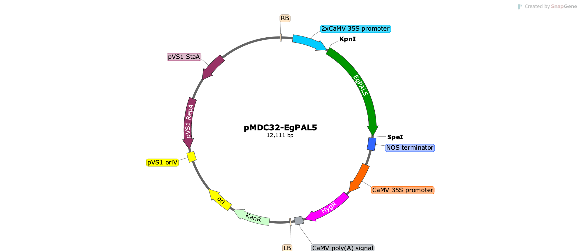

Figure 1 Plasmid map of the pMDC32-EgPAL5 construct developed for delivering the EgPAL5 gene into tobacco. RB, right border; 2x CaMV 35S promoter; EgPAL5, Elaeis guineensis phenylalanine ammonia-lyase 5 gene; NOS, nopaline synthase terminator; CaMV 35S, CaMV 35S promoter; Hyg^{R}, hygromycin B resistance gene; CaMV poly(A) signal; LB, left border

3.2 Plant and Agrobacterium Preparation

In this study, surface-sterilisation of tobacco seeds with 0.5% sodium hypochlorite for 10 min effectively eliminated microbial contaminants while preserving viability. The wild-type tobacco seeds germinated within four days on MS medium (Figure 2a), consistent with reports by Hilman et al. [25]. As shown in Figure 2b, the seedlings developed uniformly after being sown on the medium. To avoid overcrowding, the tobacco seedlings were cultured at a density of 20–25 seedlings per plate over four weeks to yield robust plant materials for genetic transformation. Meanwhile, A. tumefaciens carrying the pMDC32-EgPAL5 construct was streaked onto selective LB agar medium (Figure 2c) and incubated at 28 °C three days before genetic transformation was performed. A single colony was selected to inoculate liquid LB medium supplemented with appropriate antibiotics. The culture was grown overnight with agitation at approximately 250 rpm to maintain adequate aeration and nutrient distribution, ensuring a sufficient yield of actively growing bacterial cells for plant transformation. The culture medium changed from clear to turbid appearance during growth and multiplication of A. tumefaciens (Figure 2d). This indicates a high bacterial density and a homogenous population, appropriate for the subsequent infection process.

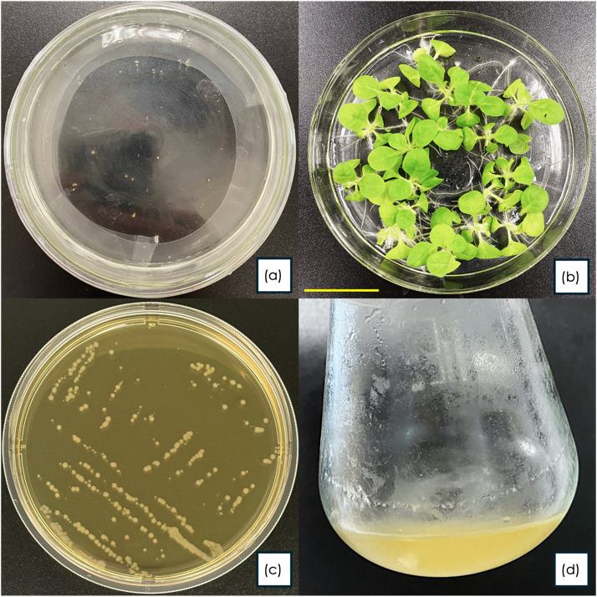

Figure 2 Preparation of plant material and bacterial culture for genetic transformation (a) surface-sterilised tobacco seeds cultured on MS medium, (b) four-week-old WT tobacco, (c) A. tumefaciens LBA4404 harbouring the pMDC32-EgPAL5 construct cultured on LB agar, (d) A. tumefaciens liquid culture used for plant transformation

3.3 Transformation and Co-cultivation

The bacterial cells were collected by centrifugation of bacterial culture at 4 °C and 4,000 × g to ensure optimal cell recovery while minimising stress to preserve Agrobacterium viability prior to infection (Figure 3a). To enhance bacterial infection occurrence, minor wounds were purposely created during leaf disc excision. As reported by [31], wounding of explants promotes Agrobacterium infection and improves transformation efficiency. This is attributed to the release of plant-derived wound signals, which activate bacterial virulence (vir) gene expression, thereby facilitating bacterial entry and subsequent T-DNA transfer into the host genome [31]. Leaf discs were immersed in the infection medium for 30 min with gentle agitation to promote uniform bacterial attachment and T-DNA transfer initiation. Post-infection, discs were blotted dry to remove excess bacteria. This is a critical step to prevent Agrobacterium overgrowth that could compromise explant viability (Figure 3b). Explants were spaced evenly across the medium, to further suppress bacterial overgrowth (Figure 3c). The co-cultivation period was strictly maintained to avoid Agrobacterium overgrowth.

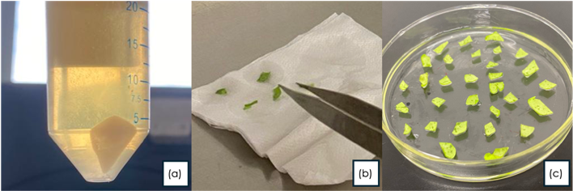

Figure 3 Genetic transformation of WT tobacco (a) bacterial cell pellet after centrifugation, (b) dry-blotting of infected leaf discs using sterile forceps, (c) explants uniformly distributed on co-cultivation medium

3.4 Regeneration of Putative Transgenics

When cultured on shooting medium I (SM1), the leaf discs exhibited distinct curling initially, and callus formation was observed at the wounded edges (Figure 4a) within 10–14 days, subsequently developing multiple shoot primordia (Figure 4b). Individual shoots were excised and subcultured onto shooting medium II (SM2) to promote nodal development and elongation (Figure 4c). Since the SM2 contained a lower concentration of BAP, the shoot primordia developed into healthy shoots. After two weeks on SM2, healthy individual shoots were transferred to a rooting medium (RM), where robust root systems developed. During the shoot regeneration and rooting steps, subculturing was performed every two weeks. Regular subculturing prevented nutrient depletion and maintained actively growing cultures throughout the regeneration period. A total of 45 plantlets were regenerated with root lengths of 1.5–2.0 cm (Figure 4d), all of which were transferred to soil for acclimatisation (Figure 4e). Forty-two putative transgenic plants were successfully established under controlled conditions, with minimal transplant shock observed as plastic covers were gradually opened during the acclimatisation period. During the vegetative growth stage, all putative transformants exhibited normal morphology, showing healthy leaf expansion, sturdy stems, and consistent structural vigour, indicating stable regeneration under the optimised protocol.

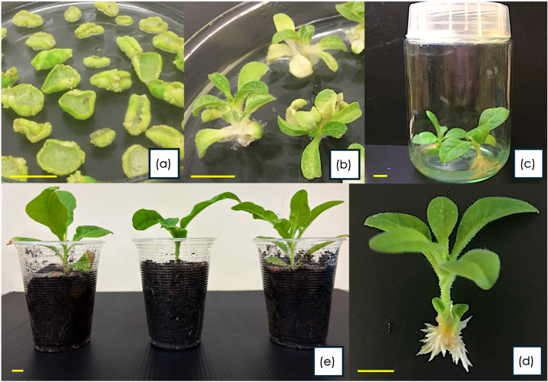

Figure 4 Regeneration of putative transgenic tobacco plants (a) Leaf explants (0.5–1.0 cm²) placed on SM1, (b) shoot organogenesis with multiple shoot buds developing from induced callus, (c) elongated individual shoots isolated into culture vessel, (d) rooted plantlet ready for acclimatisation, (e) acclimatised regenerant in soil substrate (scale bar = 1 cm)

3.5 Molecular Verification of Transgenics

Due to labour and time constraints, only 10 vigorous plants were selected and subjected to molecular verification. To verify the presence of the EgPAL5 gene in tobacco genome, gDNA samples were first extracted from the selected plants (Figure 5a). Agarose gel electrophoresis analysis of the gDNA samples revealed distinct, high-molecular-weight bands, confirming that the gDNA was intact and suitable for subsequent PCR analysis. As anticipated, PCR analysis yielded a distinct amplicon of the expected size (about 2.1-kb) from all samples (Figure 5b). The result demonstrated both the specificity of the primers used and the integration of the EgPAL5 gene in the tobacco genome. To unequivocally confirm the identity and fidelity of the integrated sequence, the PCR product from a representative transgenic line was cloned and subjected to Sanger sequencing. The sequencing result confirmed that the amplified PCR product corresponding to the coding sequence of EgPAL5. The chromatogram (Figure 5c) shows that the obtained sequence data was high quality and interpretable.

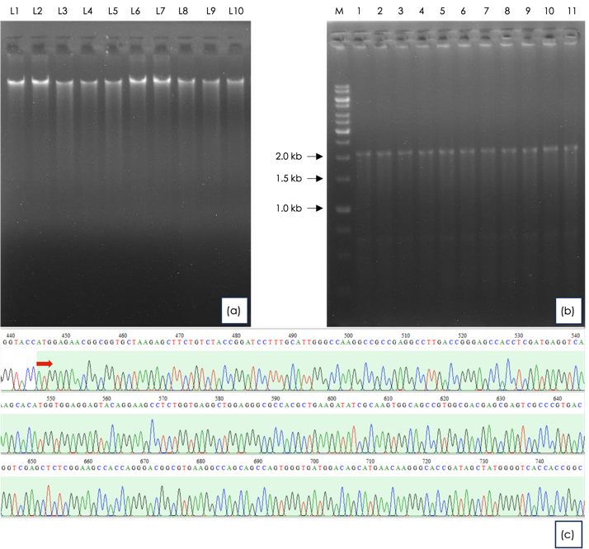

Figure 5 Molecular verification of EgPAL5 transgene integration in transgenic tobacco plants (a) Genomic DNA samples isolated from putative transgenic lines. Lanes L1–L10: Lines 1–10, (b) PCR amplification of the EgPAL5 transgene in transgenic tobacco lines; Lane M: 1 kb DNA ladder (1st BASE, Singapore); Lanes 1–10: transgenic lines L1–L10; Lane 11: positive control (pMDC32-EgPAL5 plasmid was used as the PCR template), (c) Sanger sequencing chromatogram of the PCR product cloned in pJET1.2 vector. The arrow indicates the start codon (ATG) of the EgPAL5 gene
Taken together, the results confirmed that transgenic tobacco plants carrying EgPAL5 gene from oil palm have been successfully produced in this study. The present work focused on the generation and molecular verification of transgenic tobacco harbouring the EgPAL5 gene, rather than the functional characterisation of the gene. Therefore, no in-depth molecular and biochemical characterisations such as gene expression analysis and enzymatic assays, was performed on the transgenic plants generated in this study. Future studies should prioritise the selection of independent transgenic lines exhibiting elevated PAL activity to ensure the attainment of the desired outcomes. In addition, field evaluations of the stress tolerance of the transgenic tobacco should be performed to verify whether the generated transgenic plants indeed manifest enhanced resilience under stress conditions. Apart from being an elite variety for tobacco production, the transgenic plants produced in this study can also serve as valuable material for elucidating the functional role of the EgPAL5 gene in future studies. The development of transgenic tobacco varieties with enhanced stress tolerance may facilitate the translation from laboratory findings into practical field applications.

4.0 CONCLUSION

The present study successfully generated and verified transgenic tobacco lines carrying the oil palm EgPAL5 gene, demonstrating the feasibility of introducing this gene into tobacco through the Agrobacterium-mediated transformation method. As PAL plays a central role in phenylpropanoid biosynthesis, which contributes to lignin formation and plant defence responses, the transgenic lines generated were anticipated to exhibit enhanced resilience under unfavourable conditions. They also serve as useful resources for future functional and metabolic engineering studies. Ultimately, the development of transgenic tobacco followed by the characterisation of EgPAL5 has the potential to bridge laboratory findings and practical field applications. It will definitely be beneficial for both basic understanding and translational outcomes in plant stress biology.

Ethics Statement

This study was conducted in accordance with institutional biosafety guidelines under the oversight of the Universiti Teknologi MARA Institutional Biosafety Committee. The project was reviewed and classified as an exempted activity under the applicable biosafety regulations. All transgenic plant materials were handled within appropriate biosafety containment facilities. No human participants or animal subjects were involved in this study.

Acknowledgement

The pJET1.2-EgPAL5 plasmid was kindly provided by Assoc. Prof. Dr. Mohd Puad Abdullah of Universiti Putra Malaysia (UPM) Serdang, Malaysia. The authors thank the laboratory staff for facility support. This work was funded by the Ministry of Higher Education (MOHE), Malaysia, under the Fundamental Research Grant Scheme (FRGS/1/2022/STG01/UITM/02/13).

References

[1] Zhu, R., He, S., Ling, H., Liang, Y., Wei, B., Yuan, X., Cheng, W., Peng, B., Xiao, J., Wei, J., He, Y., Xiao, H., Wang, Z. 2024, Optimizing tobacco quality and yield through the scientific application of organic-inorganic fertilizer in China: a meta-analysis. Frontiers in Plant Science. Volume 15 - 2024.
DOI : https://doi.org/10.3389/fpls.2024.1500544

[2] Datiles, M. J., Acevedo-Rodríguez, P. 2022, Nicotiana tabacum (tobacco). CABI Compendium.
DOI : https://doi.org/10.1079/cabicompendium.36326

[3] Bai, Y., Pattanaik, S., Patra, B., Werkman, J. R., Xie, C. H., Yuan, L. 2011, Flavonoid-related basic helix-loop-helix regulators, NtAn1a and NtAn1b, of tobacco have originated from two ancestors and are functionally active. Planta. 234(2): p. 363-75.
DOI : https://doi.org/10.1007/s00425-011-1407-y

[4] Selwal, N., Tabassum, Z., Rahayu, F., Yulia, N. D., Sugiono, S., Endarto, O., Riajaya, P. D., Djajadi, D., Khamidah, A., Wani, A. K. 2023, Therapeutic potential and phytoremediation capabilities of the tobacco plant: Advancements through genetic engineering and cultivation techniques. Biocatalysis and Agricultural Biotechnology. 52: p. 102845.
DOI : https://doi.org/10.1016/j.bcab.2023.102845

[5] Murtaza, G., Chen, Y., Qian, F., Zheng, G., Usman, M., Azam, M., Deng, G., Ahmed, Z., Chen, S., Iqbal, J., Elshikh, M. S., Rizwana, H., Ahmad, S., Iqbal, R., Gurbanova, L., Lackner, M. 2025, Fullerene nanoparticles enhance potential of phytoremediation and safe cultivation of tobacco (Nicotiana tabacum) in cadmium contaminated soil: Tobacco proved as fullerene-philic industrial crop. Industrial Crops and Products. 233: p. 121428.
DOI : https://doi.org/10.1016/j.indcrop.2025.121428

[6] Wu, S., Gao, C., Pan, H., Wei, K., Li, D., Cai, K., Zhang, H. 2021, Advancements in tobacco (Nicotiana tabacum L.) seed oils for biodiesel production. Front Chem. 9: p. 834936.
DOI : https://doi.org/10.3389/fchem.2021.834936

[7] Naeem, M., Han, R., Ahmad, N., Zhao, W., Zhao, L. 2023, Tobacco as green bioreactor for therapeutic protein production: latest breakthroughs and optimization strategies. Plant Growth Regulation. 103(2): p. 227-41.
DOI : https://doi.org/10.1007/s10725-023-01106-w

[8] Xu, J., Chen, Z., Wang, F., Jia, W., Xu, Z. 2020, Combined transcriptomic and metabolomic analyses uncover rearranged gene expression and metabolite metabolism in tobacco during cold acclimation. Scientific Reports. 10(1): p. 5242.
DOI : https://doi.org/10.1038/s41598-020-62111-x

[9] Wei, K., Liu, G., Wei, B., Zhang, Q., Wu, S., Li, Z. 2025, Effects of drought stress on the physiological characteristics of flue-cured tobacco during the vigorous growing period. Phyton-International Journal of Experimental Botany. 94(4): p. 1287-98.
DOI : https://doi.org/10.32604/phyton.2025.062385

[10] Sun, H., Sun, X., Wang, H., Ma, X. 2020, Advances in salt tolerance molecular mechanism in tobacco plants. Hereditas. 157(1): p. 5.
DOI : https://doi.org/10.1186/s41065-020-00118-0

[11] Cacal, D., Ricafrente, D., Cacayurin, C., Soriano, R. 2024, Effects of tobacco (Nicotiana tabacum) applied with gibberellic acid (GA3) in response to different durations of drought and flooding. Thai Journal of Agricultural Science. 57(2): p. 109− 19.

[12] Zhang, M., Ren, Q., Wu, X., Liu, M., Zhang, L., Yuan, Q., Lu, N., Cao, Y. 2025, Biocontrol potential of four Pseudomonas strains against tobacco black shank disease. Antonie Van Leeuwenhoek. 118(6): p. 83.
DOI : https://doi.org/10.1007/s10482-025-02092-x

[13] Yang, L., Yang, W., Zhang, H., Li, L., Liu, J., Li, M., Xu, R., Xiang, H., Li, Y., Yang, Y. 2026, Fusarium wilt disease induced changes in the composition and function of the rhizosphere metabolome and microbiome in tobacco plants. Scientific Reports.
DOI : https://doi.org/10.1038/s41598-026-40653-w

[14] Katawczik, M., Mila, A. L. 2012, Plant age and strain Ralstonia solanacearum affect the expression of resistance of tobacco cultivars to Granville wilt. Tobacco Science. 49(49): p. 8-13.
DOI : https://doi.org/10.3381/11-013r.1

[15] Li, C., Zhang, Q., Wang, X., Liu, Z., Zhang, X., Jiang, C., Cheng, L., Yang, A., Li, Y., Ji, Y., Liu, D. 2025, Transcriptomic and metabolomic analyses reveal molecular mechanisms of tobacco mosaic virus (TMV) resistance in Nicotiana tabacum L. BMC Plant Biol. 25(1): p. 1029.
DOI : https://doi.org/10.1186/s12870-025-07053-0

[16] Ahmed, H., Al-Kuwaiti, N. 2025, Detection and biocontrol of Tobamovirus tabaci infecting tomato in Iraq. Jurnal Hama dan Penyakit Tumbuhan Tropika. 25: p. 158-68.
DOI : https://doi.org/10.23960/jhptt.125158-168

[17] Rifkind, D., Freeman, G. L. 11 - Tobacco mosaic virus. The Nobel Prize Winning Discoveries in Infectious Diseases. London: Academic Press; 2005. p. 81-4.
DOI : https://doi.org/10.1016/B978-012369353-2/50018-7

[18] Sarala, K., Rao, K. P., Nanda, C., Baghyalakshmi, K., Darvishzadeh, R., Gangadhara, K., Rajappa, J. J. Abiotic stress resistance in tobacco: Advances and strategies. In: Kole C, editor. Genomic Designing for Abiotic Stress Resistant Technical Crops. Cham: Springer International Publishing; 2022. p. 329-427.
DOI : https://doi.org/10.1007/978-3-031-05706-9_10

[19] Vogt, T. 2010, Phenylpropanoid biosynthesis. Mol Plant. 3(1): p. 2-20.
DOI : https://doi.org/10.1093/mp/ssp106

[20] Yadav, V., Wang, Z., Wei, C., Amo, A., Ahmed, B., Yang, X., Zhang, X. 2020, Phenylpropanoid pathway engineering: An emerging approach towards plant defense. Pathogens. 9(4).
DOI : https://doi.org/10.3390/pathogens9040312

[21] Zhang, C., Wang, X., Zhang, F., Dong, L., Wu, J., Cheng, Q., Qi, D., Yan, X., Jiang, L., Fan, S., Li, N., Li, D., Xu, P., Zhang, S. 2017, Phenylalanine ammonia-lyase2.1 contributes to the soybean response towards Phytophthora sojae infection. Sci Rep. 7(1): p. 7242.
DOI : https://doi.org/10.1038/s41598-017-07832-2

[22] Chen, Y., Li, F., Tian, L., Huang, M., Deng, R., Li, X., Chen, W., Wu, P., Li, M., Jiang, H., Wu, G. 2017, The phenylalanine ammonia lyase gene LjPAL1 is involved in plant defense responses to pathogens and plays diverse roles in Lotus japonicus-Rhizobium symbioses. Mol Plant Microbe Interact. 30(9): p. 739-53.
DOI : https://doi.org/10.1094/mpmi-04-17-0080-r

[23] Pant, S. R., Irigoyen, S., Liu, J., Bedre, R., Christensen, S. A., Schmelz, E. A., Sedbrook, J. C., Scholthof, K. B. G., Mandadi, K. K. 2021, Brachypodium phenylalanine ammonia lyase (PAL) promotes antiviral defenses against Panicum mosaic virus and its satellites. mBio. 12(1).
DOI : https://doi.org/10.1128/mBio.03518-20

[24] Yusuf, C. Y. L., Nawawi, O., Azhari, M. F., Hilman, M. S., Bai, T., Zhang, C., Yi, H., Ni, Z., Xie, D., Abdullah, M. O., Abdul Masani, M. Y., Shaharuddin, N. A., Abdullah, M. P., Ong Abdullah, J. 2026, Functional characterisation of the EgPAL5 promoter from oil palm (Elaeis guineensis Jacq.) reveals its potential roles in plant growth and adaptation to drought. The Journal of Horticultural Science and Biotechnology. 101(1): p. 58-75.
DOI : https://doi.org/10.1080/14620316.2025.2519330

[25] Hilman, M. S., Omar, N., Azhari, M. F., Bai, T., Zhang, C., Abdullah, M. P., Masani, M. Y. A., Yusuf, C. Y. L. 2025, A comprehensive method to generating and identifying transgenic tobacco lines with a single transgene integration locus for functional analysis. Pertanika Journal of Tropical Agricultural Science. 48(1).
DOI : https://doi.org/10.47836/pjtas.48.1.03

[26] Edward, K., Johnstone, C., Thompson, C. 1991, A simple and rapid method for the preparation of plant genomic DNA for PCR analysis. Nucleic Acids Research. 19(6): p. 1349.

[27] Shukor, N. A. A., Yusuf, C. Y. L., Kumar, S. M., Abiri, R., Abdullah, M. P. 2023, Molecular dissection and an in-silico approach of a novel Gibberellin 20-oxidase gene of Hibiscus cannabinus L. Pakistan Journal of Botany. 55(2): p. 489-500.
DOI : http://dx.doi.org/10.30848/PJB2023-2(11)

[28] Nawawi, O., Abdullah, M. P., Yusuf, C. Y. L. 2022, A strategy for in-house production of a positive selection cloning vector from the commercial pJET1.2/blunt cloning vector at minimal cost. 3 Biotech. 12(9): p. 216.
DOI : https://doi.org/10.1007/s13205-022-03289-x

[29] Nawawi, O., Abdullah, M. P., Yusuf, C. Y. L. 2023, A streamlined strategy for self-production of a commercial positive selection vector, the pJET1.2/blunt cloning vector, using common laboratory E. coli strains. 3 Biotech. 13(7): p. 224.
DOI : https://doi.org/10.1007/s13205-023-03647-3

[30] Nawawi, O., Hilman, M. S., Xie, D., Zhang, C., Yi, H., Shaharuddin, N. A., Ghazali, M. N., Masani, M. Y. A., Yusuf, C. Y. L. 2026, Production of transgenic Arabidopsis carrying the oil palm Eg4CL1 gene. Jurnal Teknologi. In Press.

[31] Yadav, S. K., Katikala, S., Yellisetty, V., Kannepalle, A., Narayana, J. L., Maddi, V., Mandapaka, M., Shanker, A. K., Bandi, V., Bharadwaja, K. P. 2012, Optimization of Agrobacterium mediated genetic transformation of cotyledonary node explants of Vigna radiata. SpringerPlus. 1(1): p. 59.
DOI : https://doi.org/10.1186/2193-1801-1-59

